Particulate-level changes in the water

After using the Ck-12 computer simulation of the phase changes, draw what you think happened to the water particles in each part of your experiment in the previous lesson.

Part 1- Icy water
What is changing in the state of matter of the water?
What is changing in the temperature?
Draw in the box below what is happening to the water particles.

Part 2- Liquid water
What is changing in the state of matter of the water?
What is changing in the temperature?
Draw in the box below what is happening to the water particles.

Part 3- Boiling water
What is changing in the state of matter of the water?
What is changing in the temperature?
Draw in the box below what is happening to the water particles.

Energy Bar Charts

Information about Energy Bar Charts:
- Each bar chart can represent a system, or part of a system, represented by the O in the diagram. Write the name of the system in the circle.
- Different bars in the graphs represent can represent the kinetic and potential energy of the molecules in the system.
- The arrow and block represent energy moving out (or into) the system.
- Changes in the bars from beginning to end show the transfer of energy in or out of the system, and also the transformation of energy in the system. For the potential energy, solids=1 bar, liquids= 2 bars, gases= 4 bars.
Draw your energy bar chart to explain the energy transfer in the water evaporation experiment here:

KE PE KE PE
initial
final
energy flow
How does this Energy Bar Chart connect to the observations you made of the water evaporation?
_______________________________________________________________________________________________________________________________________________________________________________________________________________________________________________________________

For each of the situations described below, use an energy bar chart to represent the ways that energy is stored in the system and flows into or out of the system. Below each diagram describe how the particle position in the electric field (PE) and particle motion (KE) change from the initial to the final state.

1. A cup of hot coffee cools as it sits on the table.

KE PE KE PE
initial
final
energy flow

2. A can of cold soda warms as it is left on the counter.

KE PE KE PE
initial
final
energy flow
3. A tray of water (20 ˚C) is placed in the freezer and turns into ice cubes (- 8 ˚C)

KE PE KE PE
initial
final
energy flow

4. Where does the energy that leaves the system in #3 go? How does this energy transfer affect the room temperature in the kitchen? Do you have any experience that supports your answer?

5. One of the ice cubes described in #3 is placed in a glass of room temperature (25 ˚C) soft drink. Do separate bar charts for the ice cube and the soft drink.

KE PE KE PE
initial
final
energy flow

KE PE KE PE
initial
final
energy flow

Describe how the arrangement and the motion of the particles in each system change from the initial to the final state.

6. The graph below left shows the cooling curve for a substance as it freezes.
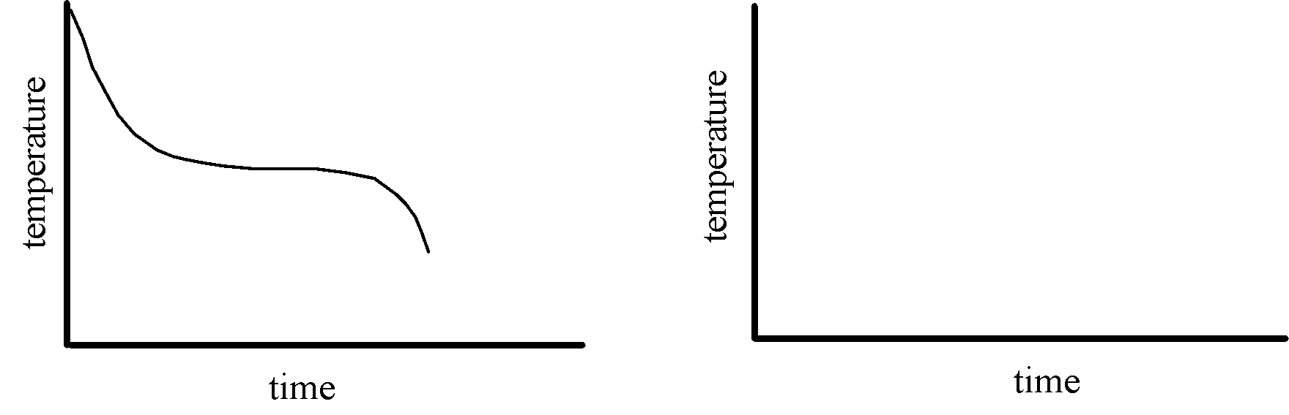
a. On the graph at right sketch the cooling curve for a larger sample of the same substance.
b. Label which phase (or phases) of the substance is present in each of the three portions of the cooling curve.
c. Describe the arrangement and motion of the particles during each portion of the graph.

